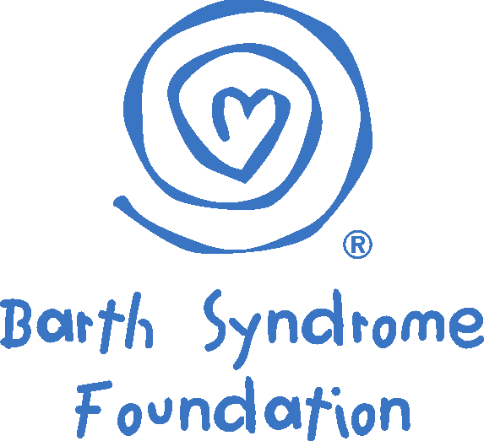

www.barthsyndrome.org

2017 BSF GRANT APPLICATION INFORMATION FORM

Principal Investigator:
Name (Last, First, Middle Initial) ____________________________________________
Title __________________________________________________________________
Department ____________________________________________________________
Institution _____________________________________________________________
Full Mailing Address _____________________________________________________
______________________________________________________________________
______________________________________________________________________
City _______________ State __________ Postal Code________ Country __________
Telephone _________________________ Fax ___________________________
E-Mail _____________________________________

Institutional Information:

Division or Department Head:
Name ________________________________________________________________
Title __________________________________________________________________
Telephone _________________________ Fax ___________________________
E-Mail _____________________________________

Authorized Institutional Officer Signing for Organization:
Name ________________________________________________________________
Title__________________________________________________________________
Mailing Address ________________________________________________________
City _______________ State __________ Postal Code________ Country __________
Telephone _________________________ Fax ___________________________
E-Mail _____________________________________

Fiscal Official to Whom Funds Should be Sent:
Name ________________________________________________________________
Title __________________________________________________________________
Mailing Address ________________________________________________________
______________________________________________________________________
City _______________ State __________ Postal Code________ Country __________
Telephone _________________________ Fax ___________________________
E-Mail _____________________________________

Exact Name of Institution or Account to Which Checks Should be Made Payable:

_____________________________________________________________________

Project Title:

______________________________________________________________________

______________________________________________________________________

Application Type:

____ Idea grant ($50,000 maximum budget; 1-2 years)
____ Development grant ($100,000 maximum budget; 2-3 years)

Is this application responding to RFA? _____Yes _____No
If Yes, what RFA? ___________________________________

Letter of Intent Sent to BSF—REQUIRED FOR DEVELOPMENT GRANT APPLICATIONS: _____Yes _____No

Proposed Starting Date for the Project: ___________________________________

Project Funding Request:
TOTAL Funds Requested $_______________(U.S.) – NOT TO EXCEED US $50,000 FOR IDEA GRANT OR $100,000 FOR DEVELOPMENT GRANT

To be Paid Over: _____ years

This Project Will Involve the Following:
Human Subjects: No ____ Yes ____ - If yes, please plan to submit institutional approval if awarded—funds cannot be issued without institutional approval

Vertebrate Animals: No ____ Yes ____ - If yes, please plan to submit institutional approval if awarded—funds cannot be issued without institutional approval

For budget purposes, PI is:
“Young Investigator”____ (non-tenured position or temporary employee)
“Established Investigator” ____ (tenured position or permanent employee)

X
X
X

I confirm that all of the information contained in this grant application is accurate and not misleading. I agree to accept responsibility for the scientific direction and conduct of this project. I certify that I have read the attached research grant policies of the Barth Syndrome Foundation, Inc. and that I will abide by them, if this grant is awarded. I acknowledge that I am aware that all decisions about grant applications made by the
Barth Syndrome Foundation, Inc. are final and are not subject to appeal.

Name of Applicant (please print) ___________________________________________

Signature of Applicant ___________________________________________________

Date _________________________________________________________________

I confirm that all of the information contained in this grant application is accurate and not misleading. I agree to accept oversight, legal and financial responsibility for this project.
I certify that I have read the attached research grant policies of the Barth Syndrome
Foundation, Inc. and that the institution I represent will abide by them, if this grant is awarded. I acknowledge that I am aware that all decisions about grant applications made by the Barth Syndrome Foundation, Inc. are final and are not subject to appeal.

Name of Institutional Officer (please print) ____________________________________

Signature of Institutional Officer ____________________________________________

Date _________________________________________________________________

BARTH RESEARCH GRANT APPLICATION BUDGET FORM/TABLE

Complete one Budget Form for the TOTAL project budget and a separate one for each year of the project (NOTE: the annual figures will serve as the basis for funds distribution -- one half of the annual amount will be disbursed semi-annually unless explicit six-month budgets are submitted in addition); list all amounts in US $.

Budget Categories as listed: Time Period: _________________

Salaries and Benefits (listed by individual):
[if PI is “Young Investigator,” then </= 75% of Direct costs]
[if PI is “Established Investigator,” then </= 10% of Direct costs]

SUBTOTAL
(Subtotal not to exceed 75% of Direct costs)
Equipment and Supplies (listed by category):

SUBTOTAL
Patient Care (itemized by type of expense):

SUBTOTAL
Other (itemized by type of expense):

SUBTOTAL
TOTAL DIRECT COSTS
TOTAL INDIRECT COSTS
(not to exceed 10% of Direct costs)
TOTAL (Direct + Indirect) COSTS
(NOT TO EXCEED US $50,000 FOR IDEA GRANTS OR
US $100,000 FOR DEVELOPMENT GRANTS OR BUDGET MAXIMUM FOR RFA GRANT AS SPECIFIED IN RFA)

