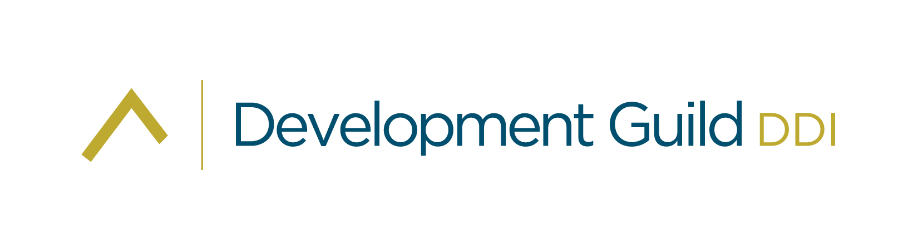

Senior Development Officer

Barth Syndrome Foundation

Remote, US | Spring 2025

Tracy Marshall

EXECUTIVE DIRECTOR, SEARCH PRACTICE

SENIOR VICE PRESIDENT, PRINCIPAL

[tmarshall@developmentguild.com](mailto:tmarshall@developmentguild.com)

**developmentguild.com**

**BOSTON | NEW YORK**

Barth Syndrome Foundation seeks an experienced Senior Development Officer to deepen and grow its donor pool to creatively develop new funding sources to help find a cure for Barth syndrome.

About Barth syndrome and the Foundation

The Barth Syndrome Foundation (BSF) is a 501(c)(3) nonprofit organization founded in 2000 with a global mission of “Saving lives through education, advances in treatments, and finding a cure for Barth syndrome.” As the world’s only organization focused on Barth syndrome, BSF is dedicated to empowering individuals and families affected by this ultra-rare genetic disorder to live their best lives while navigating its challenges.

Barth syndrome is an ultra-rare genetic condition that primarily affects males. It is characterized by a range of serious symptoms, including heart problems—especially cardiomyopathy, which causes the heart to become enlarged and weakened—muscle weakness, growth delays, and a compromised immune system. Currently, approximately 320 affected individuals are living with Barth syndrome worldwide. While treatment is primarily focused on managing symptoms, such as using heart medications for cardiomyopathy and antibiotics for neutropenia-related infections, the prognosis can improve with early diagnosis and proactive care.

BSF is deeply committed to advancing scientific and medical research to provide the option of treatments for a better tomorrow for families and individuals living with Barth syndrome. The Foundation is on the cusp of securing FDA approval for Elamipretide, a groundbreaking drug that, along with gene therapy advancements, can significantly enhance the quality of life for those affected by Barth syndrome. Though BSF is a small organization, it is mighty in its impact. With a capable and passionate team of staff and volunteers, BSF is frequently recognized for “punching way above its weight” in advancing its mission.

BSF has a world-class Scientific and Medical Advisory Board and has awarded research grants totaling over $7.0 million to 138 investigators around the globe since 2002. Carefully selected, these researchers have used grant funding to catalyze more than $40.0 million in follow-on research funding from other agencies and over $75M in support of clinical trials to date. BSF has over $5.3 million in net assets available for program investment and a 2025 operating expense budget of $2.3 million. Four international affiliate organizations in Canada, the UK, France, and Italy help to fund research globally while helping families in their local territories.

*For more information about the Barth Syndrome Foundation please visit:* [*https://www.barthsyndrome.org/*](https://www.barthsyndrome.org/)

About Philanthropy at Barth Syndrome Foundation

BSF’s philanthropic efforts have historically been driven by the generosity of individual donors, complemented by federal grants that support their biennial Scientific, Medical & Family Conferences. More recently, corporate and foundation grants have played a critical role in sustaining and expanding Barth Syndrome Foundation’s successful programs. Advances in research, particularly in the development of clinical therapeutics like gene therapy, offer exciting opportunities, but as is often the case with ultra-rare disorders, securing early-stage commercial funding remains a challenge. Increased financial support for BSF is vital for the Foundation to support families and to continuing to fund the research to better treat the disease and find a cure.

Since its inception, BSF has consistently received NIH Conference grants to support their biennial Scientific, Medical, and Family Conferences. In addition, they have recently secured program-specific grants from pharmaceutical companies, thanks to their effective advocacy efforts and clinical trial support experience. One of their notable recent achievements includes receiving a nearly $1M multi-year program grant from a prominent medical research foundation. BSF also continues to receive strong financial support from licensed affiliates across four countries, reinforcing their global impact.

BSF's fundraising strategy is built on a loyal community of donors, many of whom are connected through active volunteers, primarily consisting of families affected by the cause. Fundraising initiatives have included sponsorships tied to athletic events such as Ironman and ultra-marathons, as well as personal campaigns like birthdays, memorials, and a successful Giving Tuesday outreach. Annual events such as the NY Islanders “Hockey with a Heart” and the family-driven “Happy Heart Week” are central to BSF’s fundraising efforts. These initiatives are complemented by personalized year-end solicitation letters sent from several families to major donors. All communications include response envelopes and links to the BSF/Donor website for seamless donor engagement.

As BSF’s programs evolve and grow, so too must the approach to fundraising. While they have seen success in prior fundraising efforts, the emerging need for seed funding to support innovative trials such as gene therapy and enzyme infusion will require them to expand their fundraising strategies and resources beyond their current capabilities. It is essential to nurture and strengthen existing donor relationships while identifying and engaging new funding sources to meet these future demands.

While BSF enjoys strong, long-standing relationships with many dedicated supporters, there is a critical opportunity to expand their prospect base and engage new donors to ensure the continued growth and impact of the organization.

About the Position

The Senior Development Officer (SDO) will report directly to the Executive Director and serve as a senior and trusted leader within the organization. This individual will play a pivotal role in creating a development strategic plan, and managing and expanding BSF’s fundraising efforts, building on a robust donor base cultivated over the past two decades. The SDO will play a crucial role in collaborating with both staff and volunteer leadership to secure the additional support needed to advance BSF’s mission and continue driving progress in this critical area of research. They will be responsible for growing relationships with current supporters while actively working to broaden the organization’s donor pool.

Key Responsibilities

* Conducting a comprehensive assessment of existing fundraising efforts.
* Developing a long-term development plan in collaboration with the Executive Director, staff, board members, and key volunteers to meet organizational goals.
* Cultivating and expanding relationships with major donors, foundations, corporations, and new funding sources.
* Leading and growing a high-performing fundraising team, including staff and volunteers.
* A person and person holding a baby

  AI-generated content may be incorrect.Overseeing grant writing and identifying new grant opportunities.
* Optimizing existing fundraising programs and events while innovating new initiatives.
* Collaborating with the communications team to integrate development messaging into all outreach efforts.
* Managing donor communications, ensuring consistent and compelling messaging.
* Identifying and structuring funding opportunities for research investments, including clinical trials.
* Building strong relationships across the nonprofit, corporate, and governmental sectors to diversify funding.

Key Qualifications

* Minimum of seven years of fundraising experience, with a proven track record in major gifts, grants, and donor relations.
* Experience managing volunteers and fundraising programs focused on individual donors.
* Exceptional writing and interpersonal communication skills, with the ability to engage diverse audiences.
* Demonstrated success in grant writing and contract management.
* Creative, strategic thinker with strong project management skills.
* High emotional intelligence and the ability to connect with affected families.
* Knowledge of venture investment and intellectual property related to nonprofit funding is a plus.
* Passion for BSF’s mission and dedication to supporting the Barth syndrome community.
* Bachelor’s degree preferred.

**Compensation**

This is a full-time and salaried position starting at $150,000 and is commensurate with experience, competencies, and skillset.

**This is a remote position with limited travel required to meet with potential major individual/institutional donors, attend workshops, conferences, and BSF events as appropriate.**

**All qualified candidates will receive consideration for employment without regard to race, color, religion, sex, national origin, disability, veteran status, or any other characteristic protected by law.**

To express interest, please submit your cover letter and resume in confidence [here](https://www.developmentguild.com/current-searches/senior-development-officer-barth-syndrome-foundation/).

For more information, please visit [www.developmentguild.com](http://www.developmentguild.com).

Tracy Marshall

Executive Director, Search Practice

Senior Vice President, Principal

Development Guild DDI

About Development Guild DDI

*For 45 years, Development Guild DDI has consulted to leaders across the nonprofit spectrum. We have successfully collaborated with more than 650 clients nationwide in the sectors of health & science, education, environment, the arts, and social justice. We are experts in executive search and fundraising and are at the forefront of delivering best practice in these services.*

*With each engagement, we work in teams tailored to a client’s particular needs, providing sector-specific intelligence, cross-sector insight, and hands-on functional expertise. We combine our perspective on nonprofit leadership with our knowledge and experience in both fundraising and executive search. This distinct perspective enables us to deliver the most strategic and measurable impact.*

